Assignment 1
Section 1: Linus Command Line Tasks
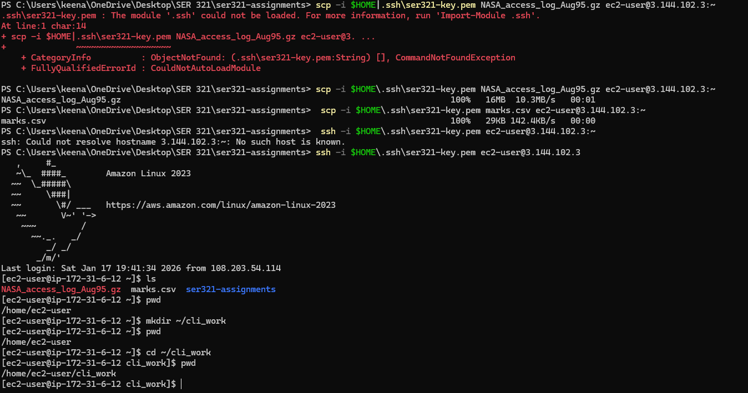
- Copying files using SCP needed for task 1
Task 1- 6
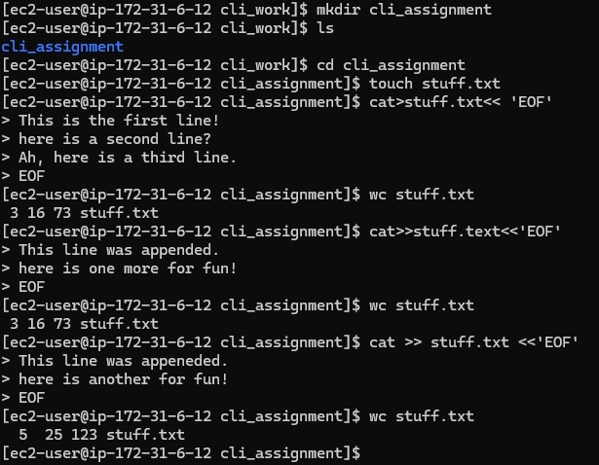

Task 7 – 10
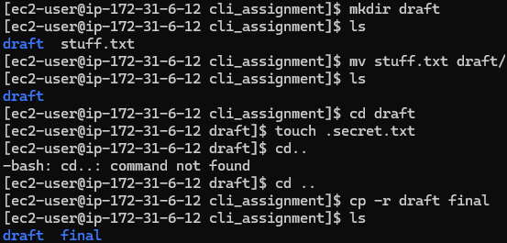

Task 11-13
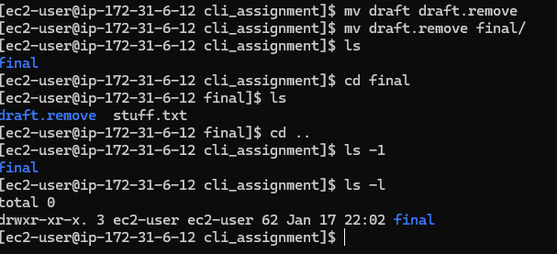

Task 14 – 17
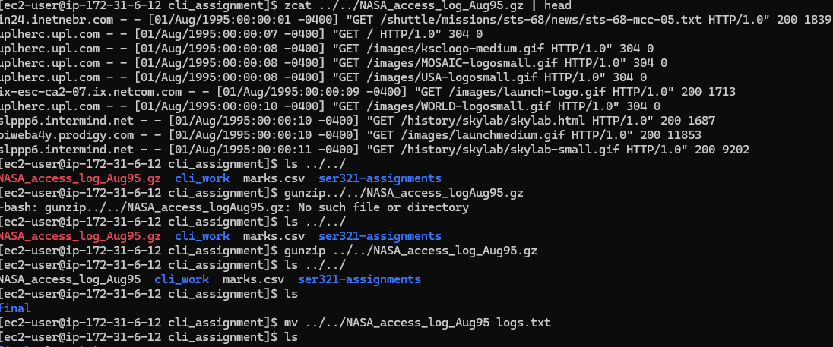

Task 18:
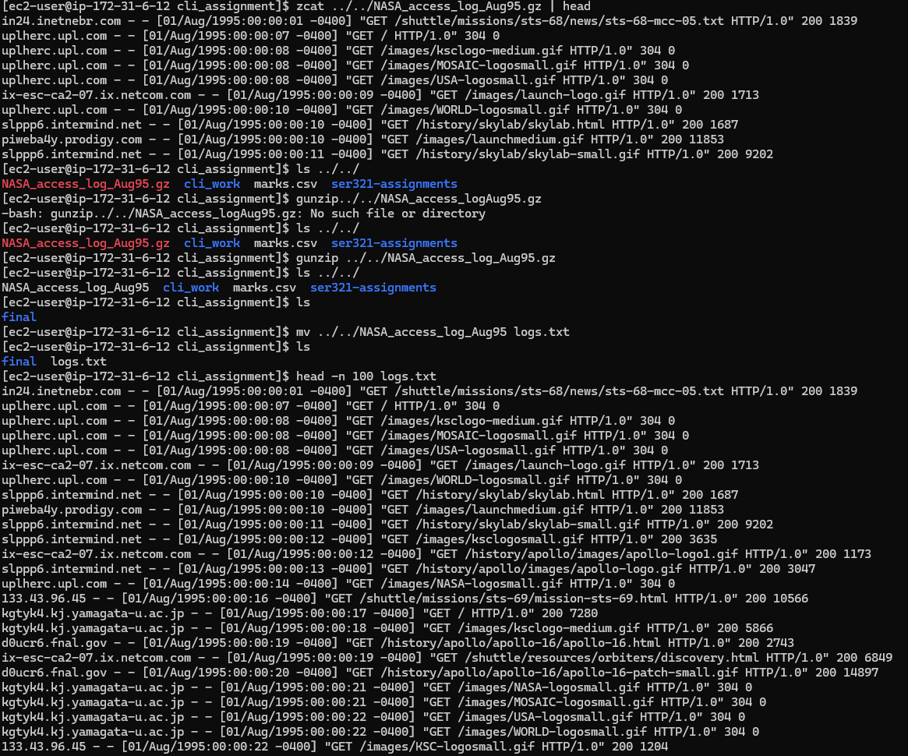
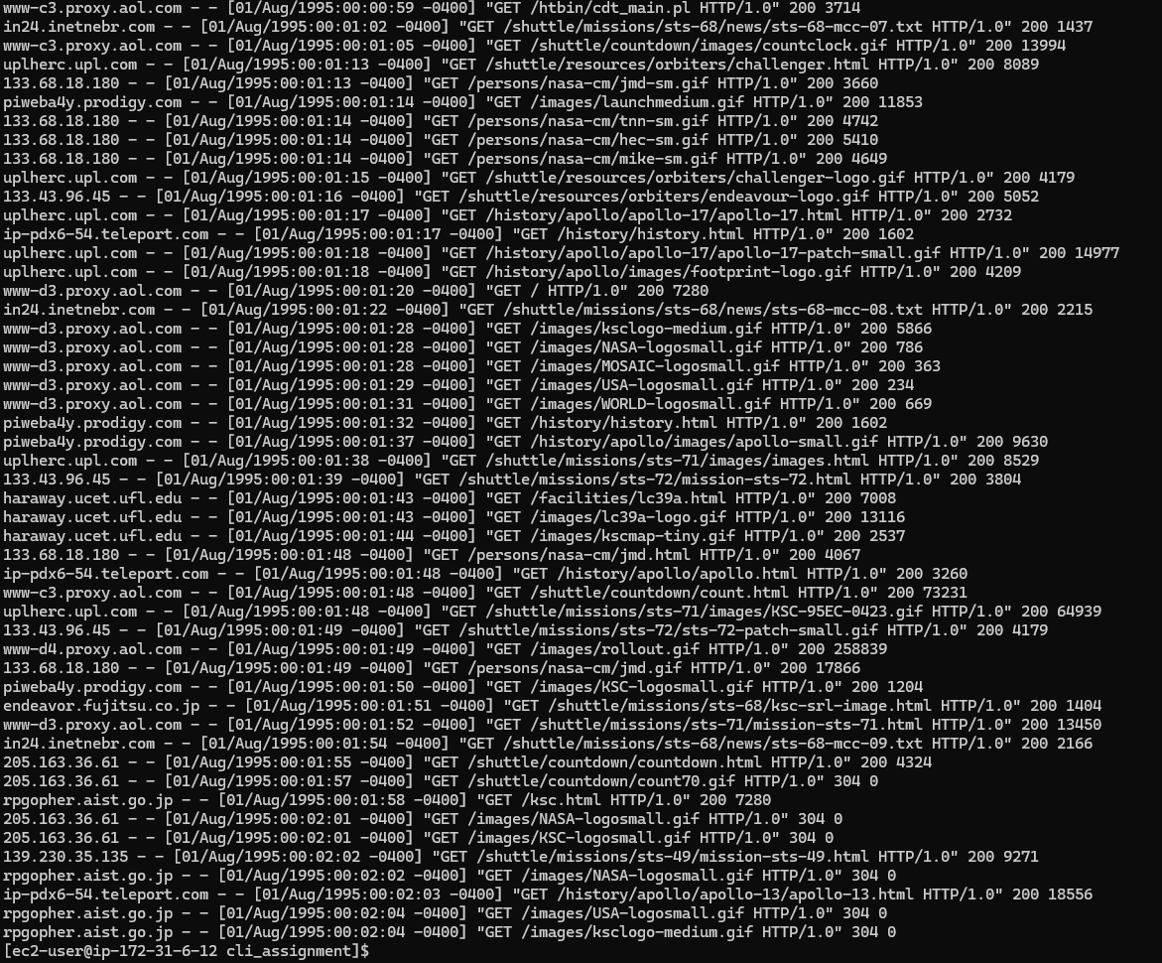
Task 19 – 20:
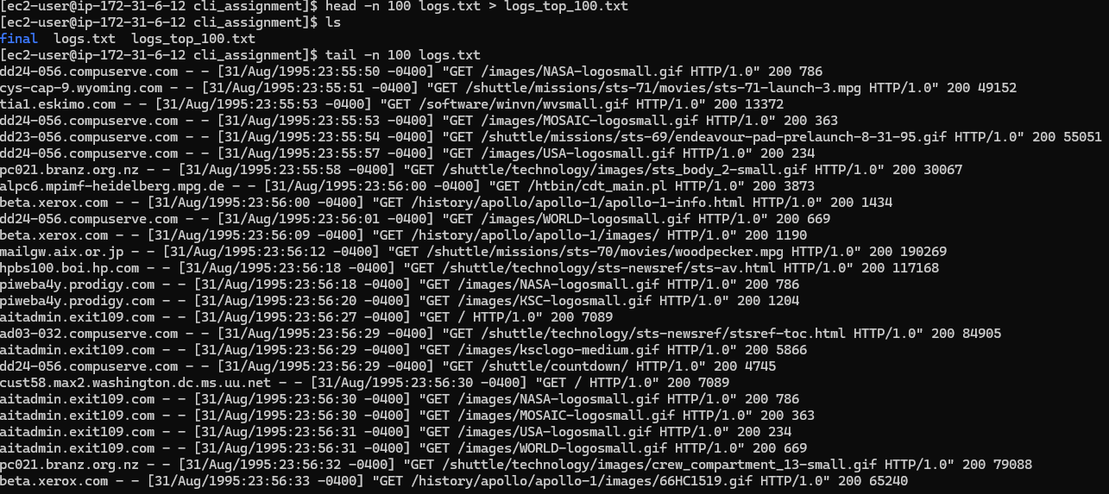
Task 21-23
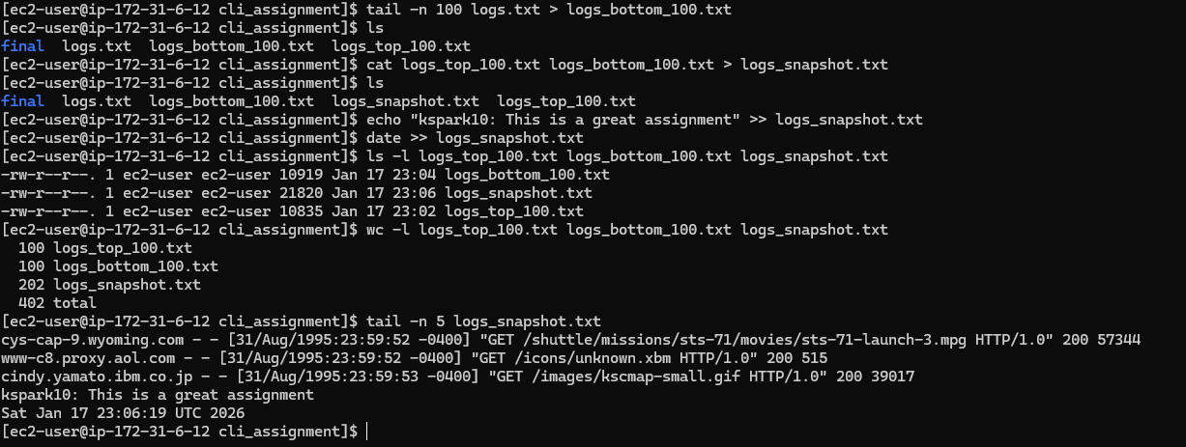
Task 24:
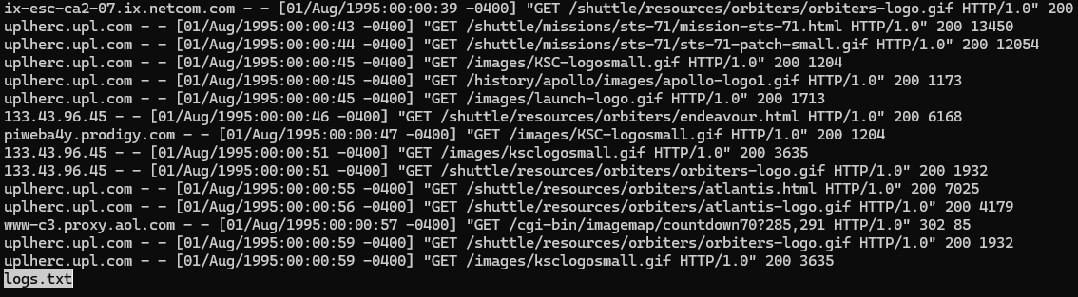

Task 25
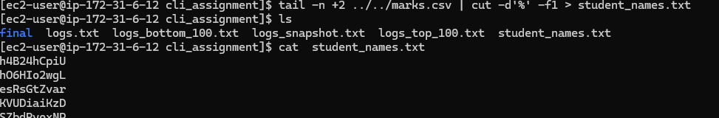

Task 26
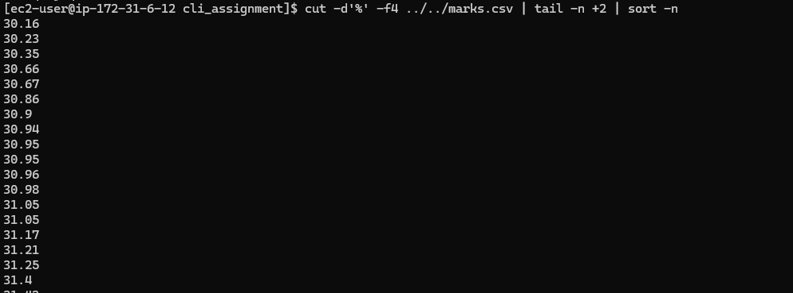
Task 27-30
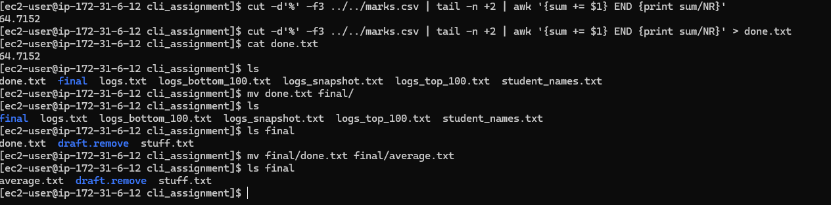
On task 27 I used the awk command to compute the average by summing allthe values from subject_2 and dividing by the total number of inputs (NR).

2.2: Running examples
Example 1: JavaGradle
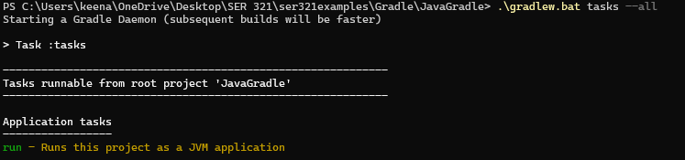
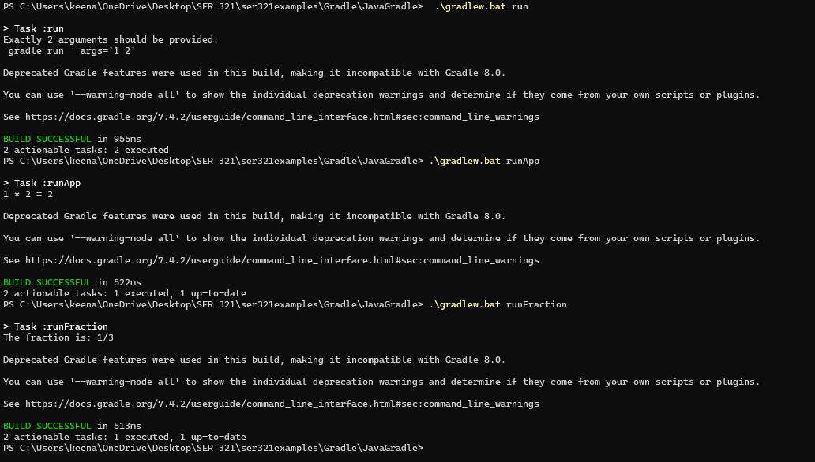
Explanation: This example has runnable task: (run, runApp, and run Fraction) that are used to demonstrate how Gradle can manage and execute different Java programs for a single project.

Example 2: JSON
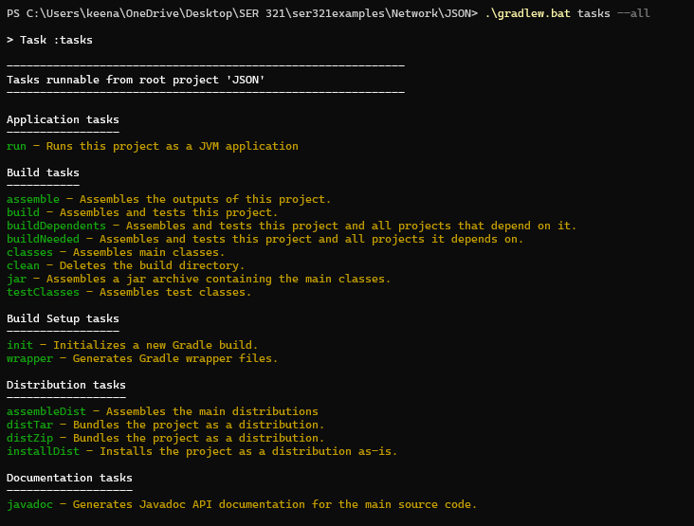
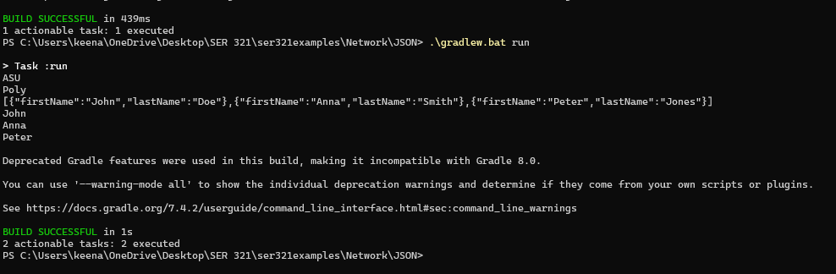
Explanation: This Program creates a list of people using KSON format. It first prints the full JASON data on the screen. Then reads through the JSON and prints each person’s first name one at a time.

Example 3: JavaThreadSock
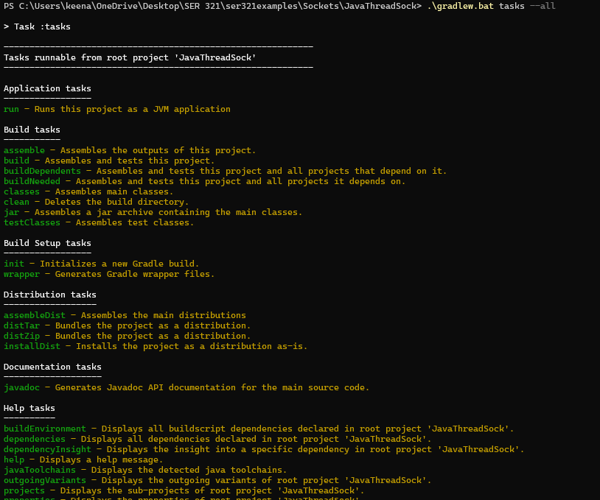
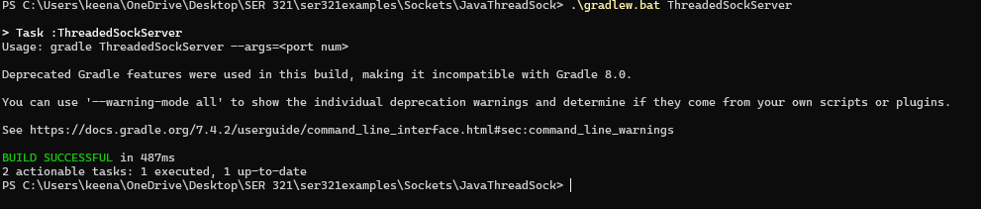
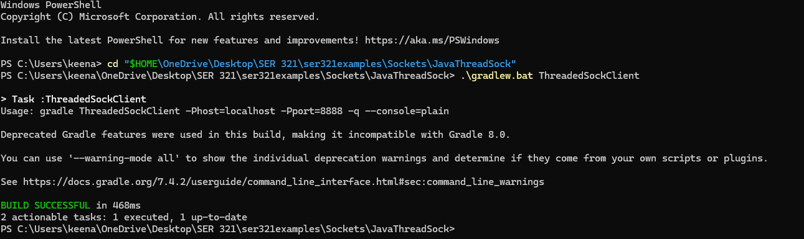
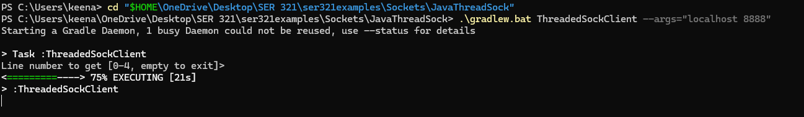
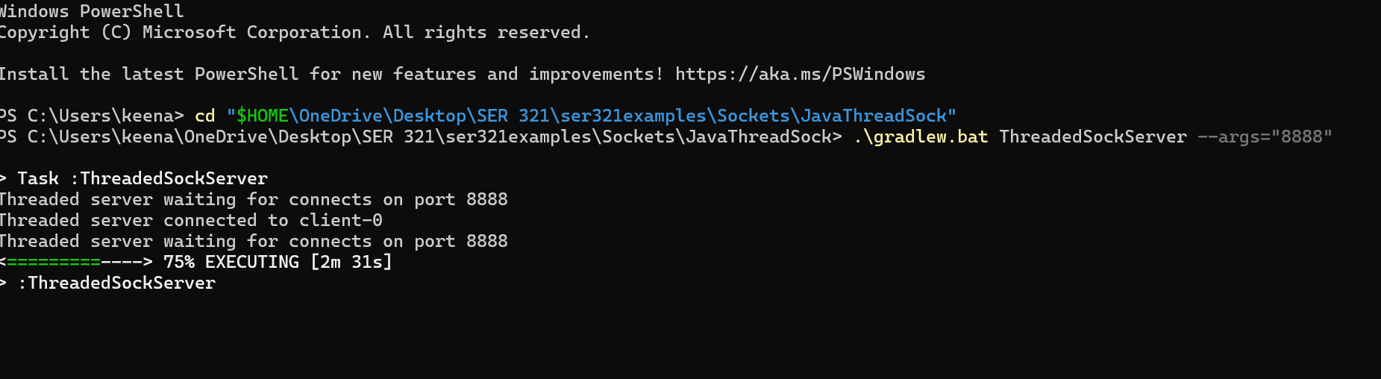

Explanation: This program demonstrates how two java programs communicate with each other. One program waits for connections, and another program connects to it.

2.4 Screen cast:
https://youtu.be/fw24sdnnevo

3.1: Understanding TCP network sockets
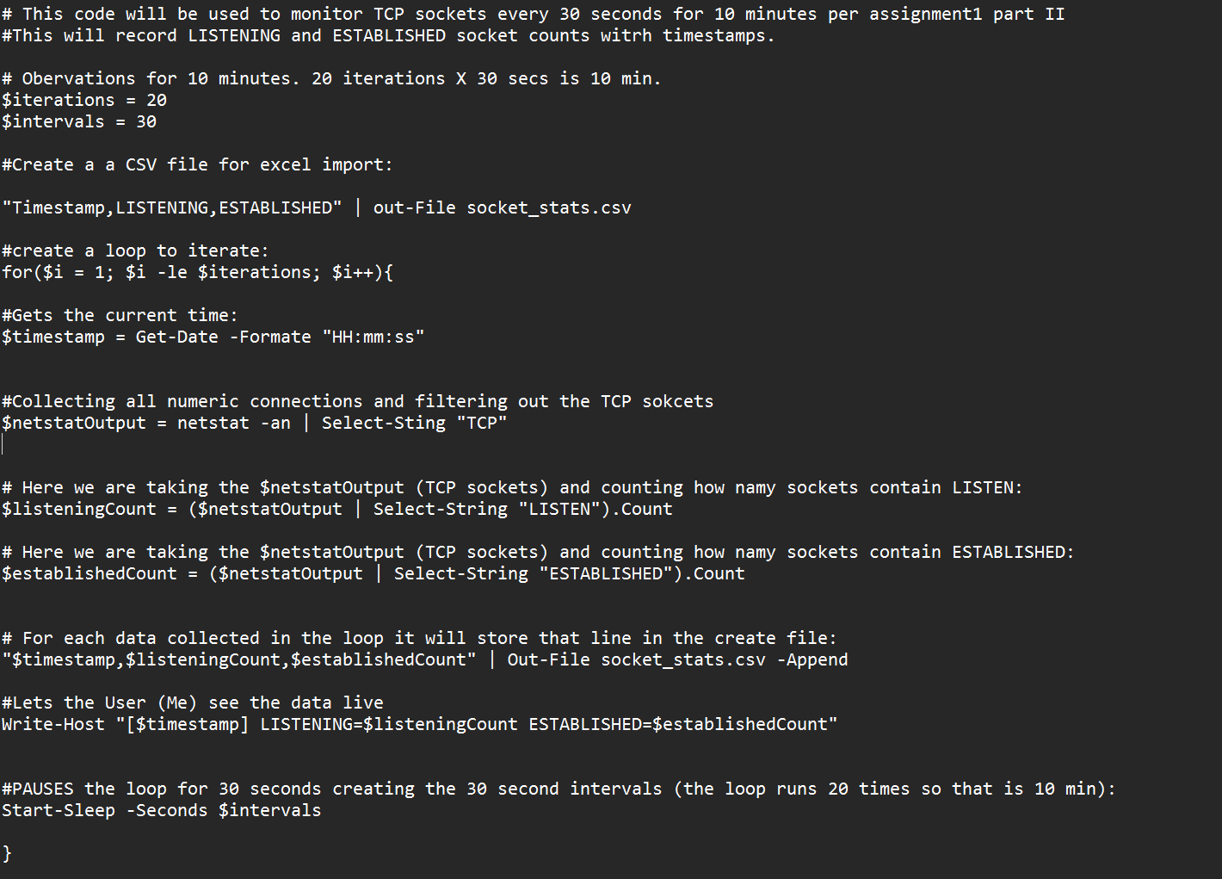
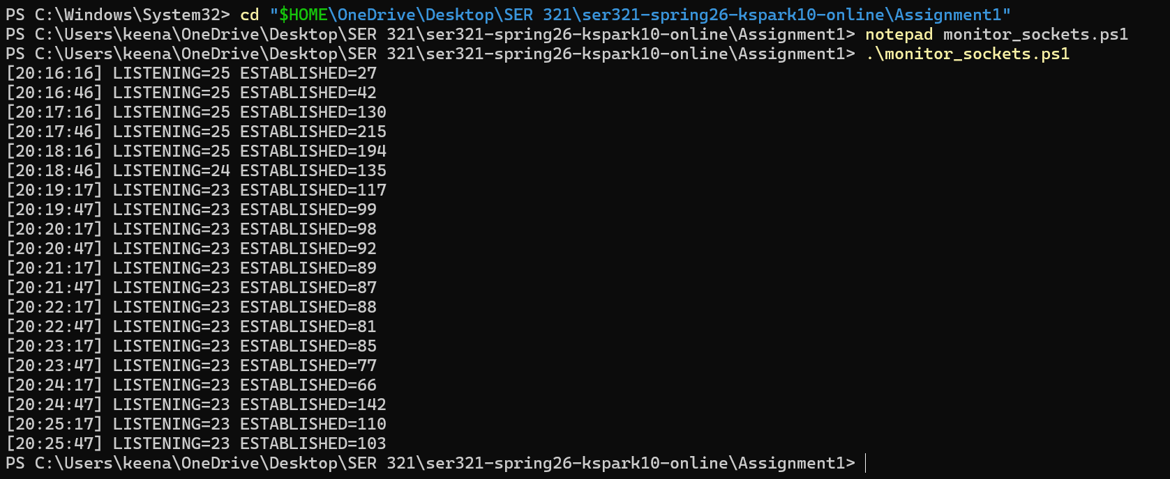

3.2: Sniffing TCP/UDP traffic
TCP Traffic:
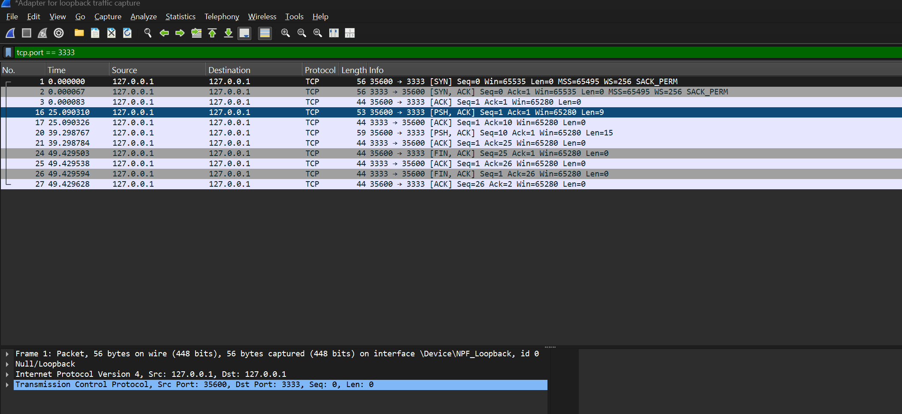
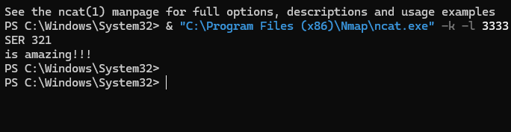
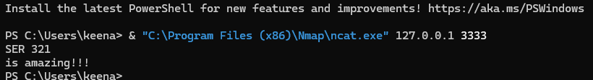
5)
- & "C:\Program Files (x86)\Nmap\ncat.exe": -k -l 3333: This creates a listen socket with Nmap (ncat). -l is listen mode for server, -k keeps server running after client disconnects. 3333 is TCP port to listen to.
& "C:\Program Files (x86)\Nmap\ncat.exe" 127.0.0.1 3333: This creates an ESTABLISHED socket that connects to localhost. The destination port is 3333 and opens TCP connection and sends typed data using ncat.

- To send the text via Push by the client then Acknowledgement by the server is needed:
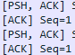
[PSH, ACK] and [ACK] – 2 packets for “SER 321”
[PSH, ACK] and [ACK] – 2 packets for “is amazing”
This means four packets are needed. This is observed in the photos provided above.

- Three-way handshake has 3 packets:
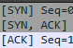
Data transfer has 4 packets:
Connection Teardown has 4 packets:
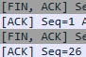
Thus, there are a total of 11 packets involved in this process.
- How many bytes are the data (only the data) that was sent from client to server?
“SER 321/r/n” – 9 bytes (This had me confused for a while. I thought it would be 8 bytes but after more digging apparently on windows machine its 9 bytes due to CRFL that OS and Linux would not use. Therefore, on a Linux or IOS machine Wireshark would show 8 bytes.)
“is amazing!!!\r\n” – 15 bytes (14 on Linux or IOS)

24 bytes of actual data, on windows OS, was sent from the client to the server.

- How many total bytes went over the wire (back and forth) for the whole process?
Bytes | reasoning
56 | SYN
56 | SYN-ACK
44 | ACK (handshake complete)
53 | PSH-ACK + (SER 321\r\n)
44 | ACK
59 | PSH-ACK + (is amazing!!!\r\n)
44 | ACK
44 | FIN-ACK
44 | ACK
44 | FIN-ACK
44 | ACK
Total 532
Bytes on wire for each transfer of data according to Wireshark:

- How much overhead was there?
Breakdown | Bytes
Application data transferred | 24
Total data transferred | 532
Overhead | 508
Percent overhead | 95.5%

UDP Traffic:
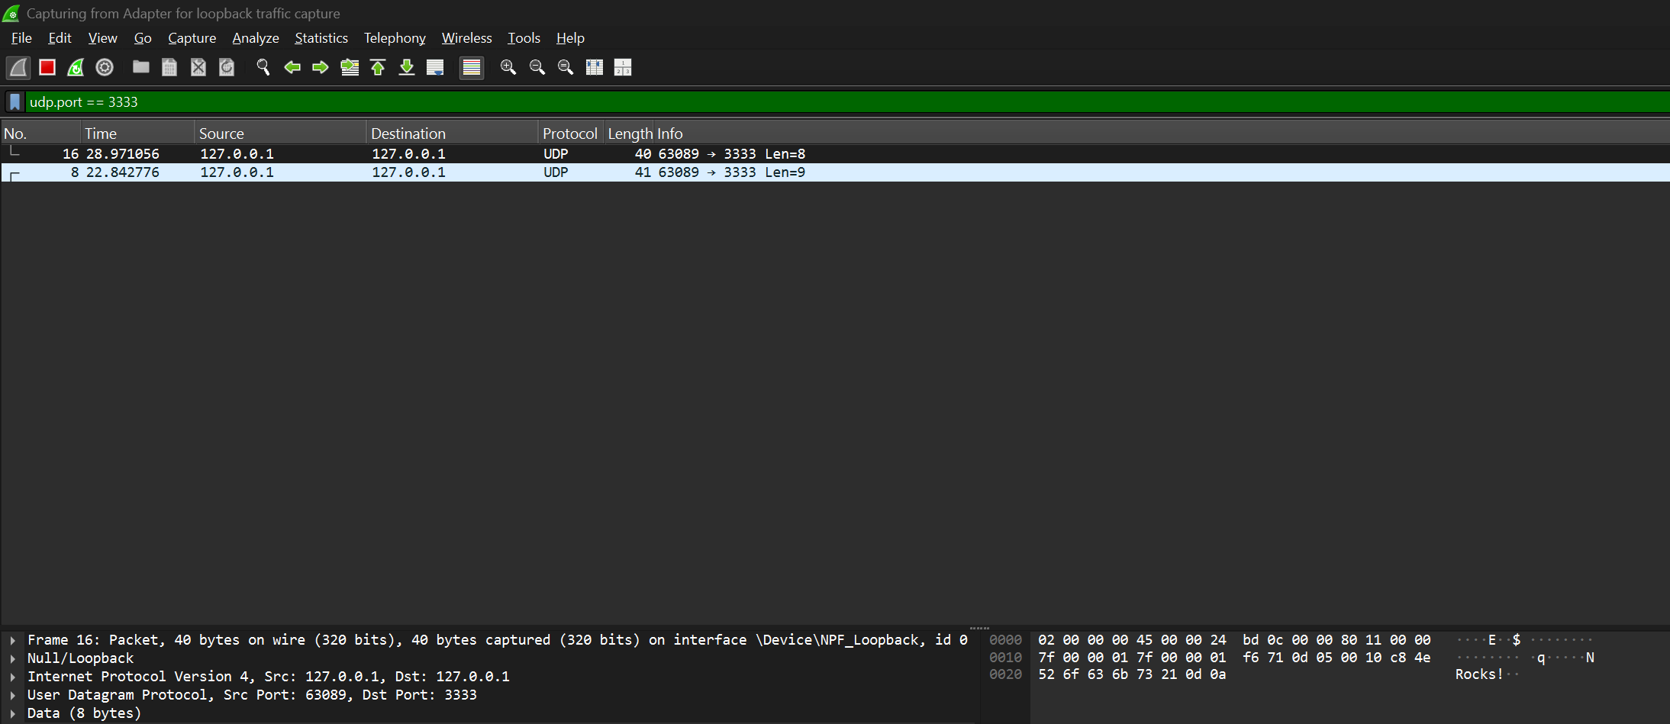
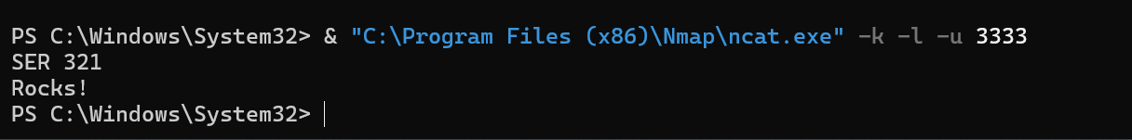
4.)
a. & "C:\Program Files (x86)\Nmap\ncat.exe" -k -l -u 3333 : This uses ncat to create a UDP socket on port 3333 in Windows PowerShell. The -l is listening mode (waiting for incoming UDP datagrams). -k keeps the server socket listening after receiving data. -u uses UDP instead of TCP.

& "C:\Program Files (x86)\Nmap\ncat.exe" -u 127.0.0.1 3333 : This creates a socket using ncat that sends UDP diagrams to the local host of 127.0.0.1 on port 3333. The -u creates a UDP socket.

b. How many packets were needed to capture those 2 lines?
2 packets:
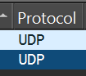

c. How many packets were needed to capture the whole "process"?
2 packets, UDP does not have ACKs, handshakes, retransmissions, or Teardown like TCP does.

d. How many bytes is the data that was sent?
“SER321\r\n” – 9 bytes
“Rocks\r\n” – 8 bytes
There are a total of 17 bytes.

e. How many total bytes went over the wire?
Packet 1 – 40 bytes
Packet 2 – 41 bytes
Total – 81 bytes

- Basically, how many bytes was the whole process compared to the actual data that we did send?
Data Transferred | Bytes
Application data | 17
Total data Transferred | 81
Overhead | 64
Percent overhead | 79%

- What is the difference in relative overhead between UDP and TCP and why?
UDP has a lower overhead than TCP because it does not perform setup, acknowledgements, sequencing, or teardown. TCP exchange SYN, SYN-ACK, ACK, sequence numbers, and FIN packets which are all absent in UDP. TCP is more reliable, but UDP is faster and lighter.

3.3 Running client servers in different ways

3.3.1 Running things locally
Link to video: https://youtu.be/rifQQwHJ890
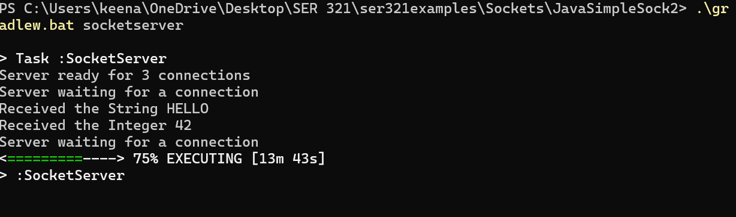
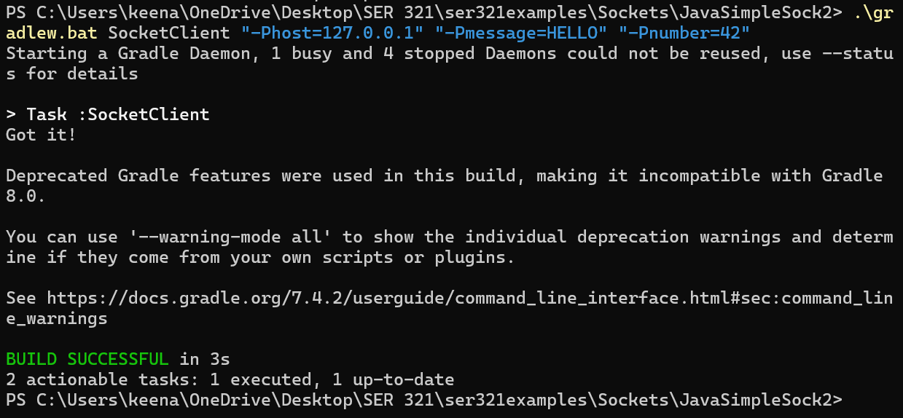
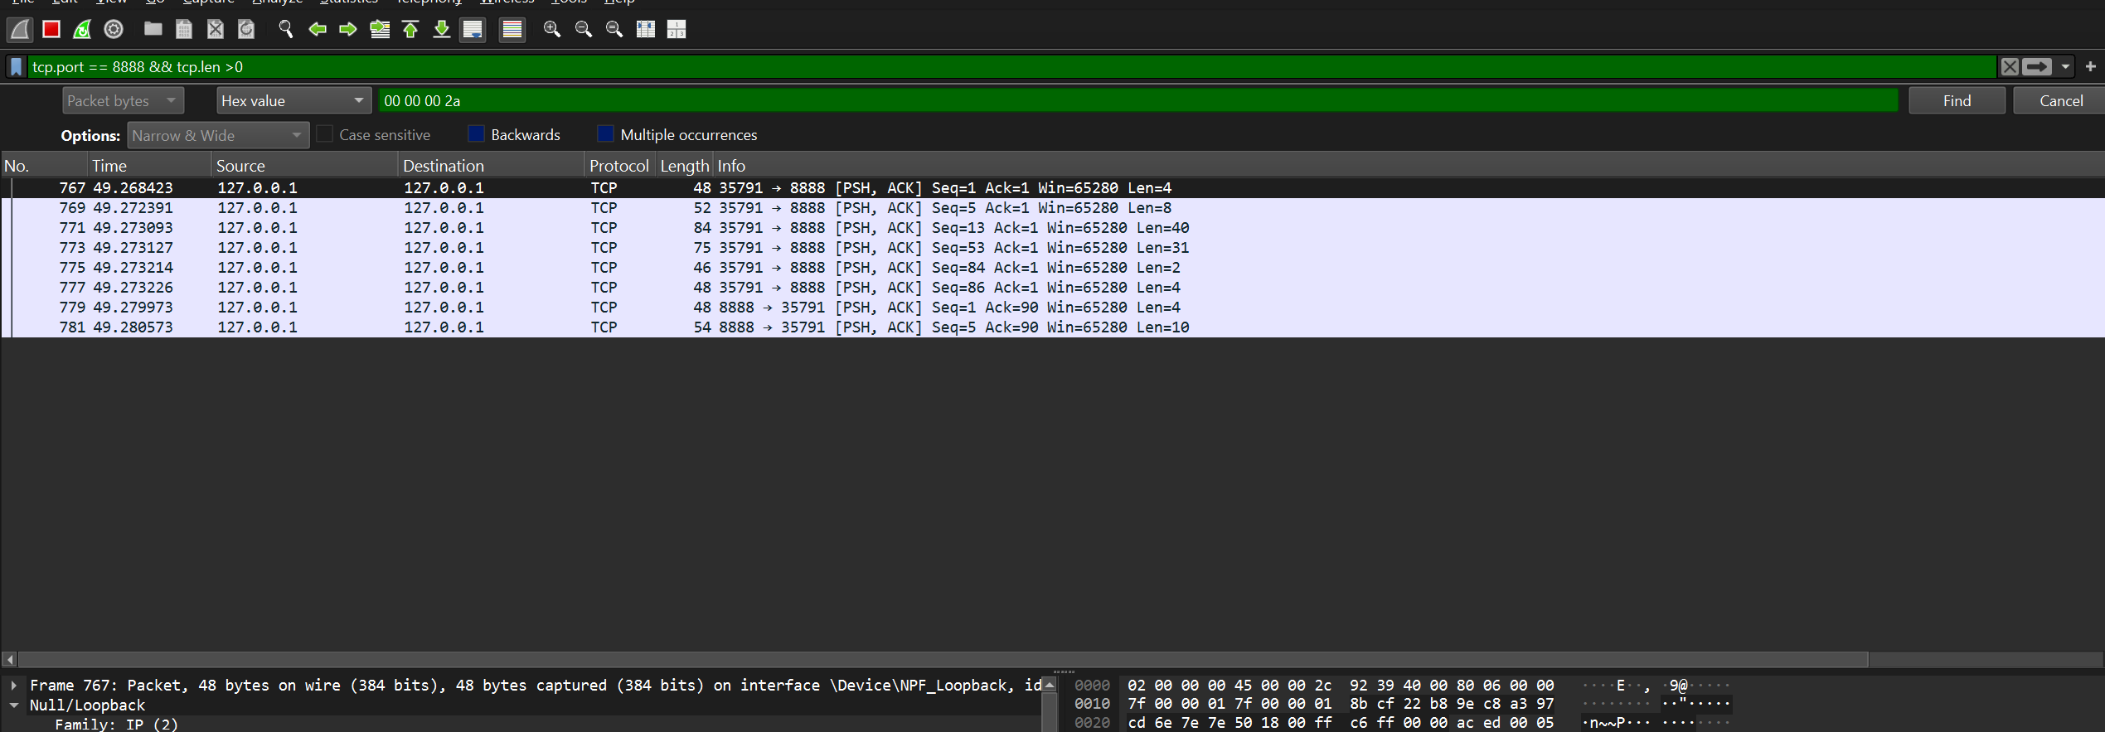

3.3.2. Server on AWS:
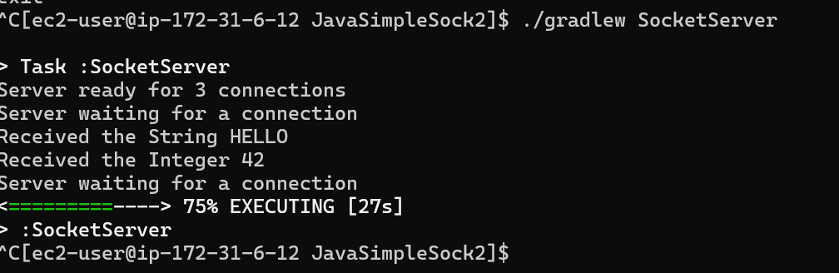
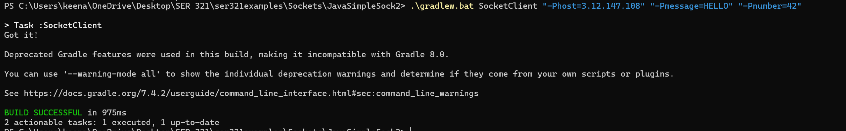
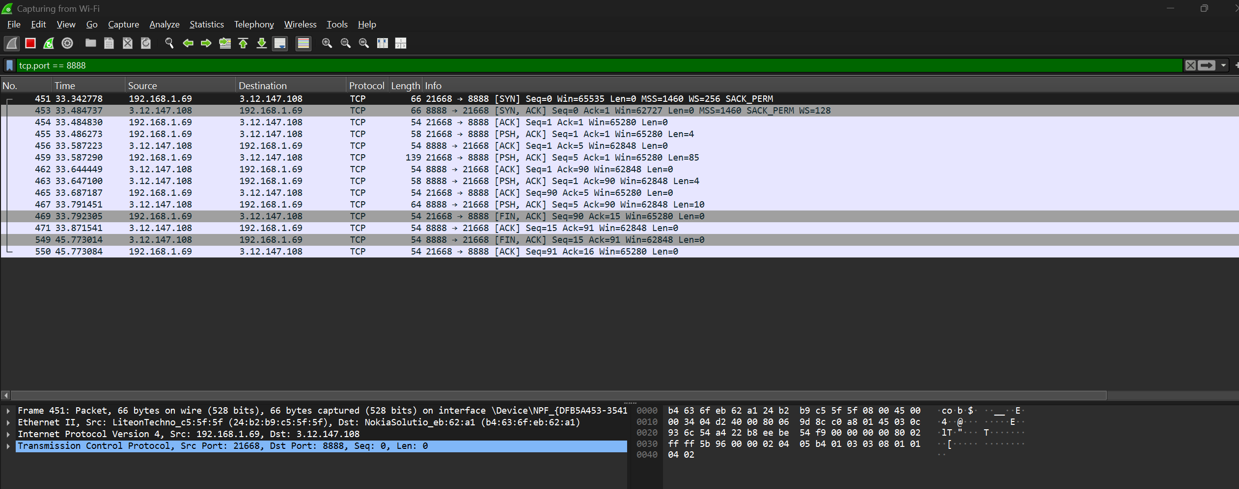

There were not any Gradle changes in the code, but I had to change the Wireshark configuration from the adapter loopback to Capture on WIFI. When the server was moved to AWS, traffic no longer used the loopback interface. Instead, packets were sent through the network stack and over the WI-FI adapter to the server’s public IP address.

3.3.3. Client on AWS
It’s hard to run a server locally and cannot be done in the same way as 3.32. Running the client on AWS and the server locally does not work by default because the local server is behind a NAT router. This blocks unwelcome inbound connections from the internet. Unlike outbound connections (which allows Return traffic back in), inbound traffic requires explicit router configuration.

3.3.4. Client on AWS 2
The difficulty in running a server locally and accessing it from AWS is caused by NAT and private IP addressing. Home routers block inbound connections by default and only allow return traffic for outbound connections initiated internally. This is why a client running locally can easily reach a server on AWS, but a client on AWS cannot directly reach a server running on a local machine without port forwarding, VPNs, or other networking configurations.

